AI ASSISTED CODING

LAB ASSIGNMENT 6.5

DATE:29-8-25

ENROLLMENT NUMBER:2403A51065

AI-Based Code Completion: Working with suggestions for classes, loops,  
conditionals  
Lab Assignment 1: Intelligent Code Completion for Object-Oriented Programming  
Objective: To explore AI-powered code assistants for writing Python classes,  
constructors, and methods through intelligent suggestions.  
Suppose that you are hired as an intern at a tech company that develops inventory  
management systems. Your manager asks you to create a Product class and a  
Warehouse class with some basic methods. You have decided to use AI-powered code  
suggestions to help speed up development and reduce syntax errors.  
Tasks to be completed are as below  
1. Setup AI Coding Tool:  
• Install and configure GitHub Copilot or Kite with VS Code or JetBrains IDE.  
• Enable real-time code suggestions

I have already installed **VS CODE** and configured the **Python extension**.  
I also installed **GitHub Copilot** in VS Code and logged in with my GitHub account.  
After enabling Copilot, I was able to see realtime code suggestions while typing Python code.

2. Class Design Using AI Assistance:  
• Begin defining a Product class with attributes: name, price, quantity.  
• Use the AI suggestion feature to automatically complete the __init__() method.  
• Add a method calculate_value() to return price * quantity.

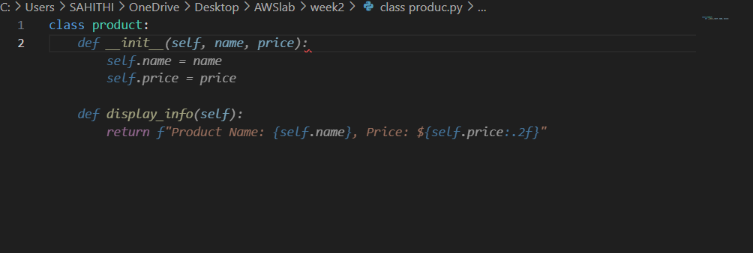

While creating a Product class with attributes name, price, and quantity.  
Copilot automatically suggested the init method when I started typing and generated the block of code which I provided in the above screenshot.I Accepted the code.

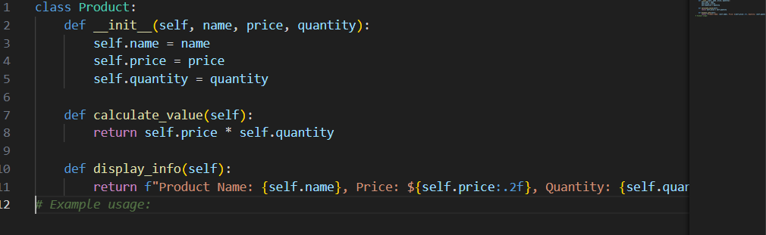

After accepting the block of code given by copilot I modified the code according to the requirements provided in the assignment. I added a calculate value() method, which was partially suggested by Copilot.

3. Create Another Class:  
• Define a Warehouse class with a list of Product objects.  
• Use code completion to help implement:  
o A method to add a product.  
o A method to display the most valuable product

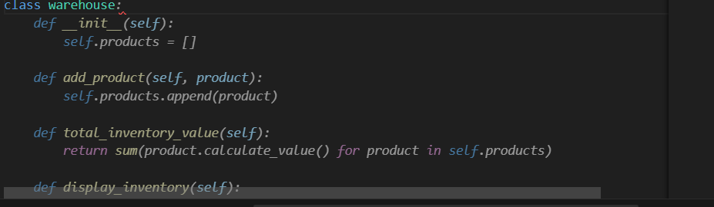

While creating another task the copilot gave the remaining block of code.But there were few errors which I rectified and updated the code.The errors I have updated are in total_inventory_value,ai gave self,products It should be self.products.Also complete code was not given by copilot.I have attached the updated code below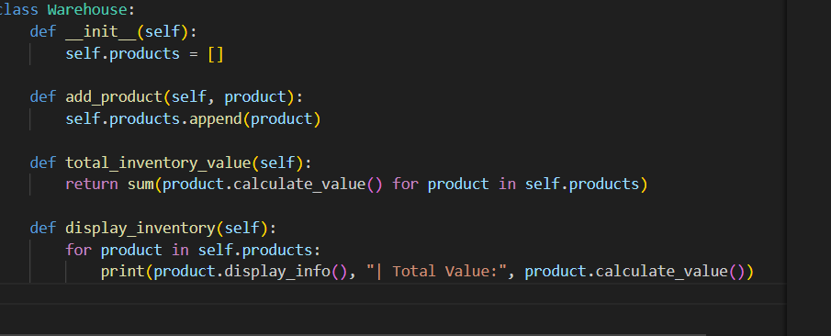

4. Reflection:  
• Identify how much of the code was completed by AI and what manual edits  
were needed.  
• Comment on the relevance and accuracy of AI suggestions

Almost 80 percent of the code was completed by AI.There were some instances where I have to update the code with given requirements,so edits like adding some functions which were partially suggested.Then there are few syntax errors like missing comms and random placement of fullstops.

I am impressed by the relevance but no much by accuracy.The code was definitely relevant but in most cases it was not accurate many updations and error fixings should be done by human for greater output.